## Candidate Information Form (CIF) – Mindtree Ltd (AIG) Project

***Instructions***: Please provide all the information requested in this form. Incomplete Candidate Information Forms will be returned for completion. **All** supporting documents **must** accompany this form. **Legible** photocopies are requested please**.**



**PART A - PERSONAL DETAILS:**

Full Name (First/Middle/Last): Aman Singh

Father’s Name: ­­­Manoj Kumar Singh

Date of birth (DD/MM/YY): 10/12/1995 Nationality: Indian

You’re Phone Number (Land Line and/or Mobile): 7974748717

Your Email ID: Aman.Singh2@mindtree.com

Social Security Number (If worked/studied in the US/Any other Country):_____________

**Change of Name if Applicable**

Former Name/Maiden Name: ____________________________

Date of Name Change: _____________________

**(Kindly Provide the Address where you resided for past 7 years, Please fill the details in BLOCK LETTERS).**

**Current Address**

Door No/House name: D-BLOCK MINDTREE KALINGA Street: SPECIAL ECONOMIC ZONE, INFOCITY

City: BHUBANESHWAR State: ODISHA PIN: 751024

Landmark: KALINGA (SEZ) : (Landline)

Period of Stay: 11th-Nov-2017 to 8th-feb-2018 (Month & Year Mandatory)

**Previous to Current Address**

Door No/House name: SBI APARTMENT, Pi-1, GB NAGAR Street: GB NAGAR

City: GREATER NOIDA State: UTTAR PRADESH PIN: 201308

Landmark: ________________________________: (Landline)

Period of Stay: 2013-2017 (Month & Year Mandatory)

**Previous to Previous Address**

Door No/House name: ARYA KUNJ, MARUTI ENCLAVE Street: TATIBANDH

City: RAIPUR State: CHHATTISGARH PIN: 492099

Landmark: ________________________________: (Landline)

Period of Stay: 2005-2013 (Month & Year Mandatory)

**Previous to Previous Address**

Door No/House name: Street: **______________________**

City: __________________State:__________________ PIN: _______ ____

Landmark: ________________________________: (Landline)

Period of Stay: _____________________________(Month & Year Mandatory)

**Previous to Previous Address**

Door No/House name: Street: **______________________**

City: __________________State:__________________ PIN: _______ ____

Landmark: ________________________________: (Landline)

Period of Stay: _____________________________

**Permanent Address**

Door No/House name: ARY KUNJ, MARUTI ENCLAVE Street: TATIBANDH

City: RAIPUR State: CHHATTISGARH PIN: 492099

Landmark: ________________________________: (Landline)

Period of Stay: 2005-PRESENT

# **Note: Please attach a legible photo copy of any two of following documents:**

1. Driving License 2. Passport 3. PAN Card 4.Others

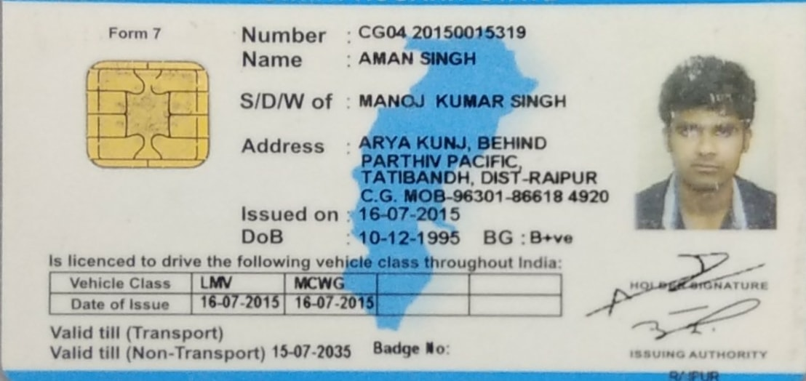

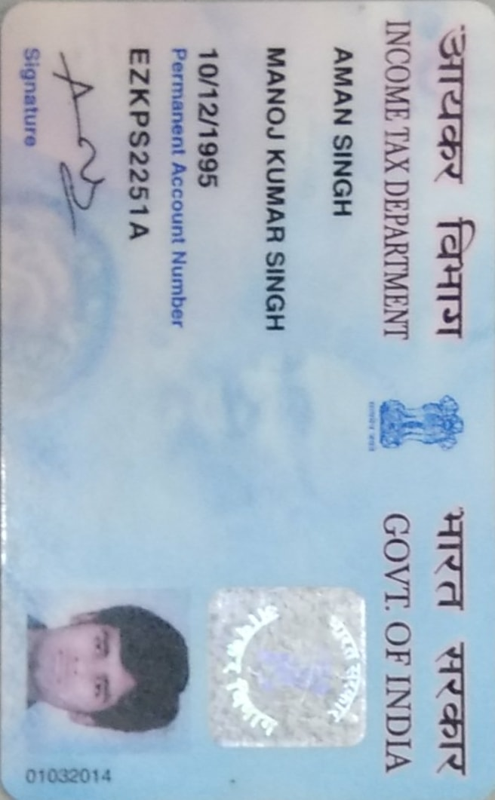

**PART B - EDUCATION DETAILS:**

|  |  |  |
| --- | --- | --- |
| **Post-Graduation** | | |
| **Name of the Institute/School/College :** | | |
| **Board/University :** | | **Division/Class/% :** |
| **Duration of Study (specify month & year):** | | **Degree Obtained :** |
| **Majored in :** | | **Course Type : Regular [ ] Distance [ ]** |
| **Student ID/Enrolment/Registration/Roll No :** | | |
| **Address of Institute/School/College** | **Building No & Street:** | |
| **City:** | **State:** |
| **Pin:** | **Landline :** |
| **Graduation** | | |
| **Name of the Institute/School/College : Galgotias University** | | |
| **Board/University : Private University** | | **Division/Class/% : 80.4 %** |
| **Duration of Study (specify month & year): 2013september -2017 may** | | **Degree Obtained : B.Tech** |
| **Majored in : Computer Science** | | **Course Type : Regular [ Yes] Distance [ ]** |
| **Student ID/Enrolment/Registration/Roll No : 13SCSE101081** | | |
| **Address of Institute/School/College** | **Building No & Street: Dhankaur** | |
| **City: Gtr Noida** | **State: UP** |
| **Pin: 201307** | **Landline :** |

# **Note: Please attach legible photo copies of the following documents relevant to the entries above.**

1. All Mark sheets 2) Degree Certificate 3) Provisional Degree Certificate

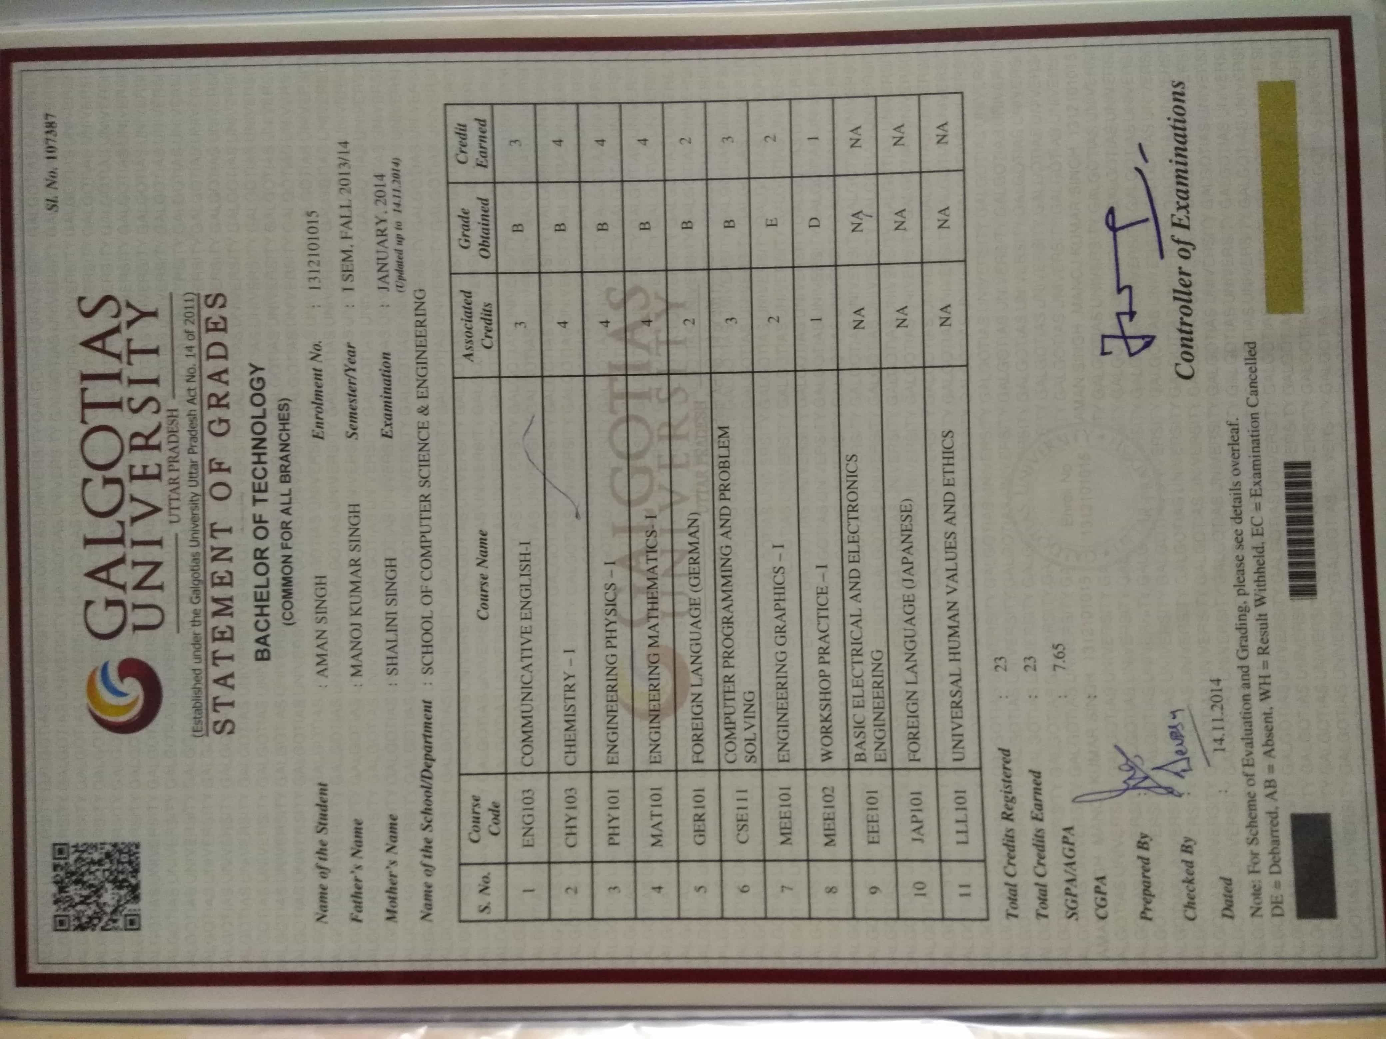

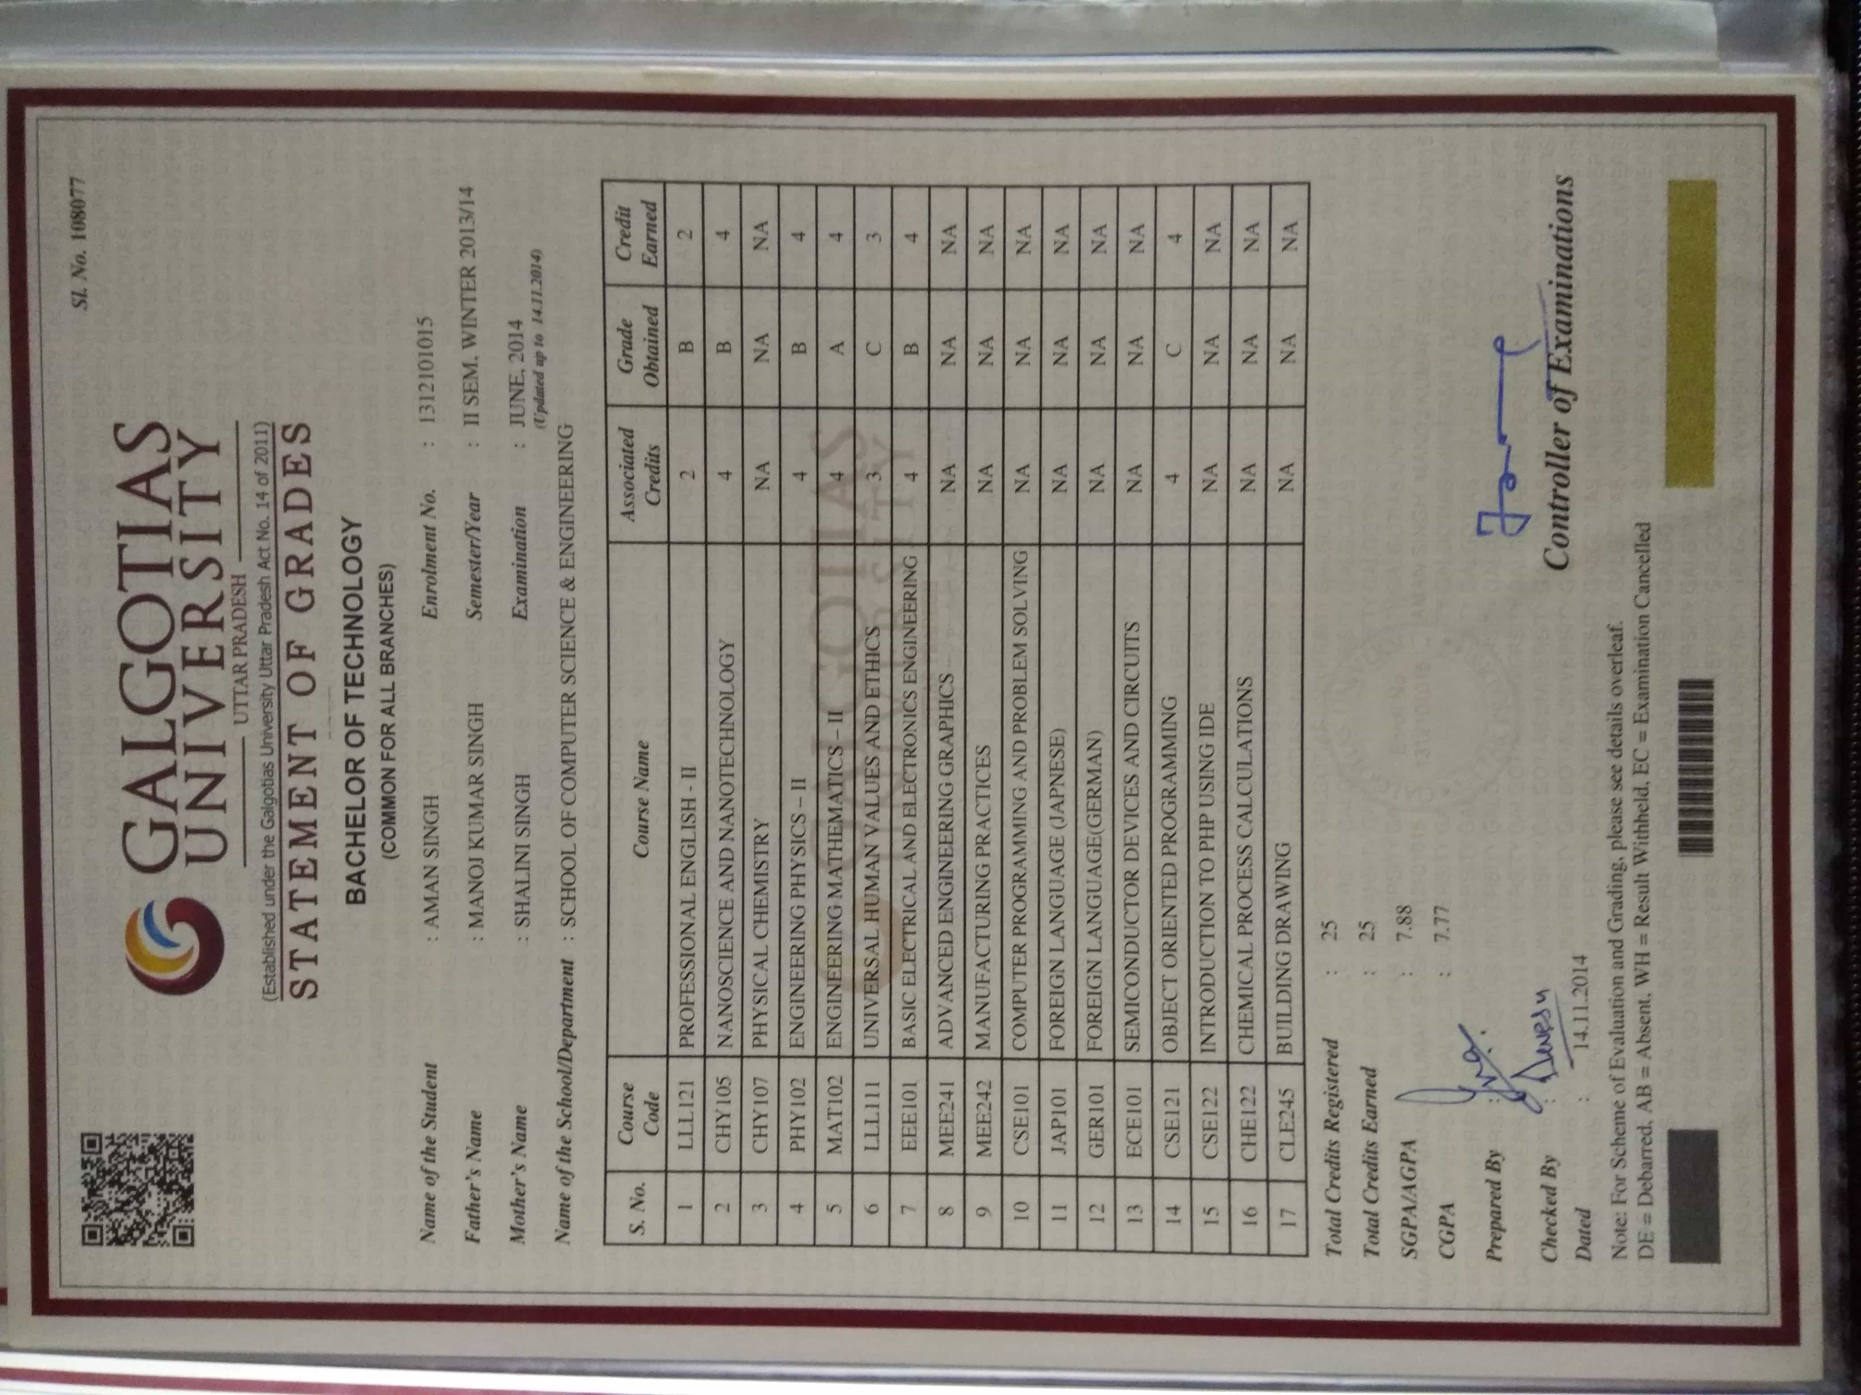

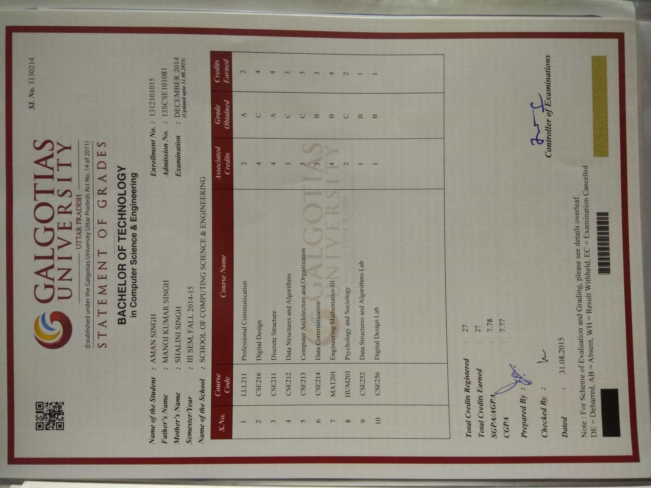

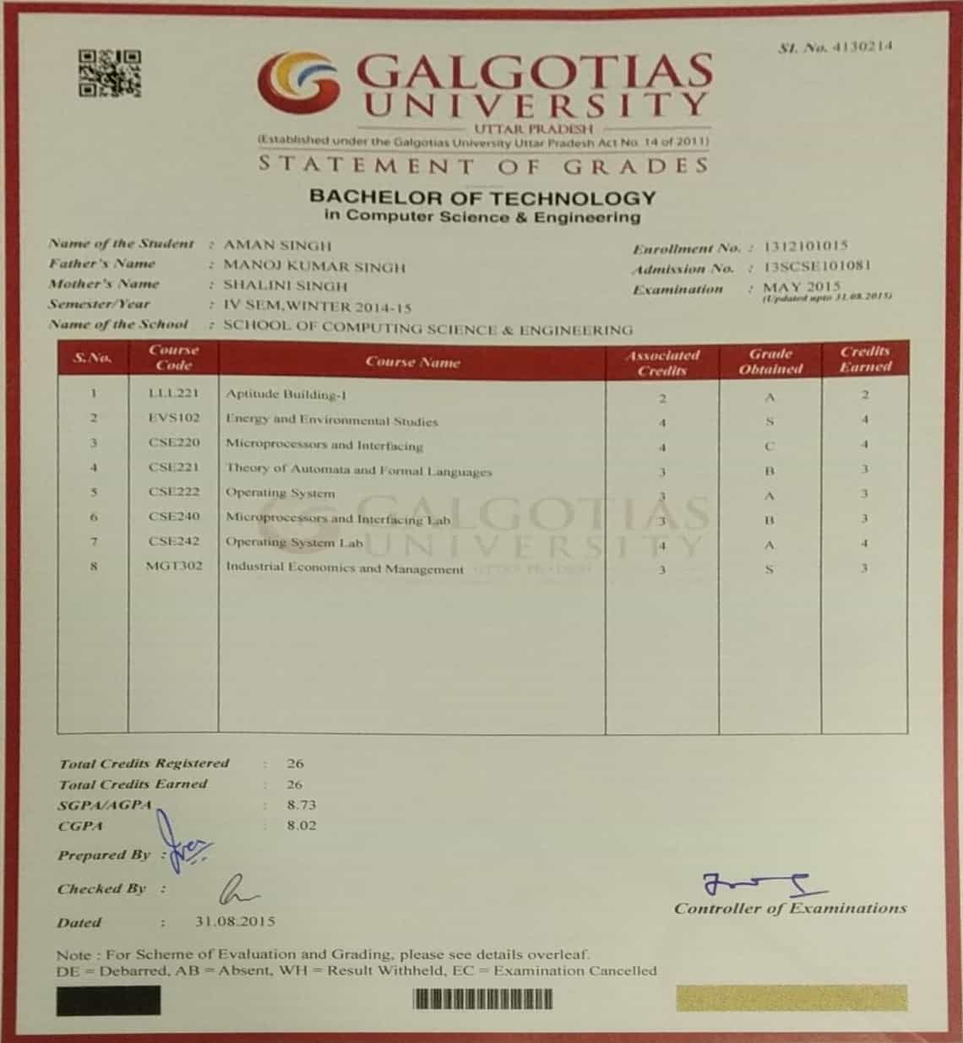

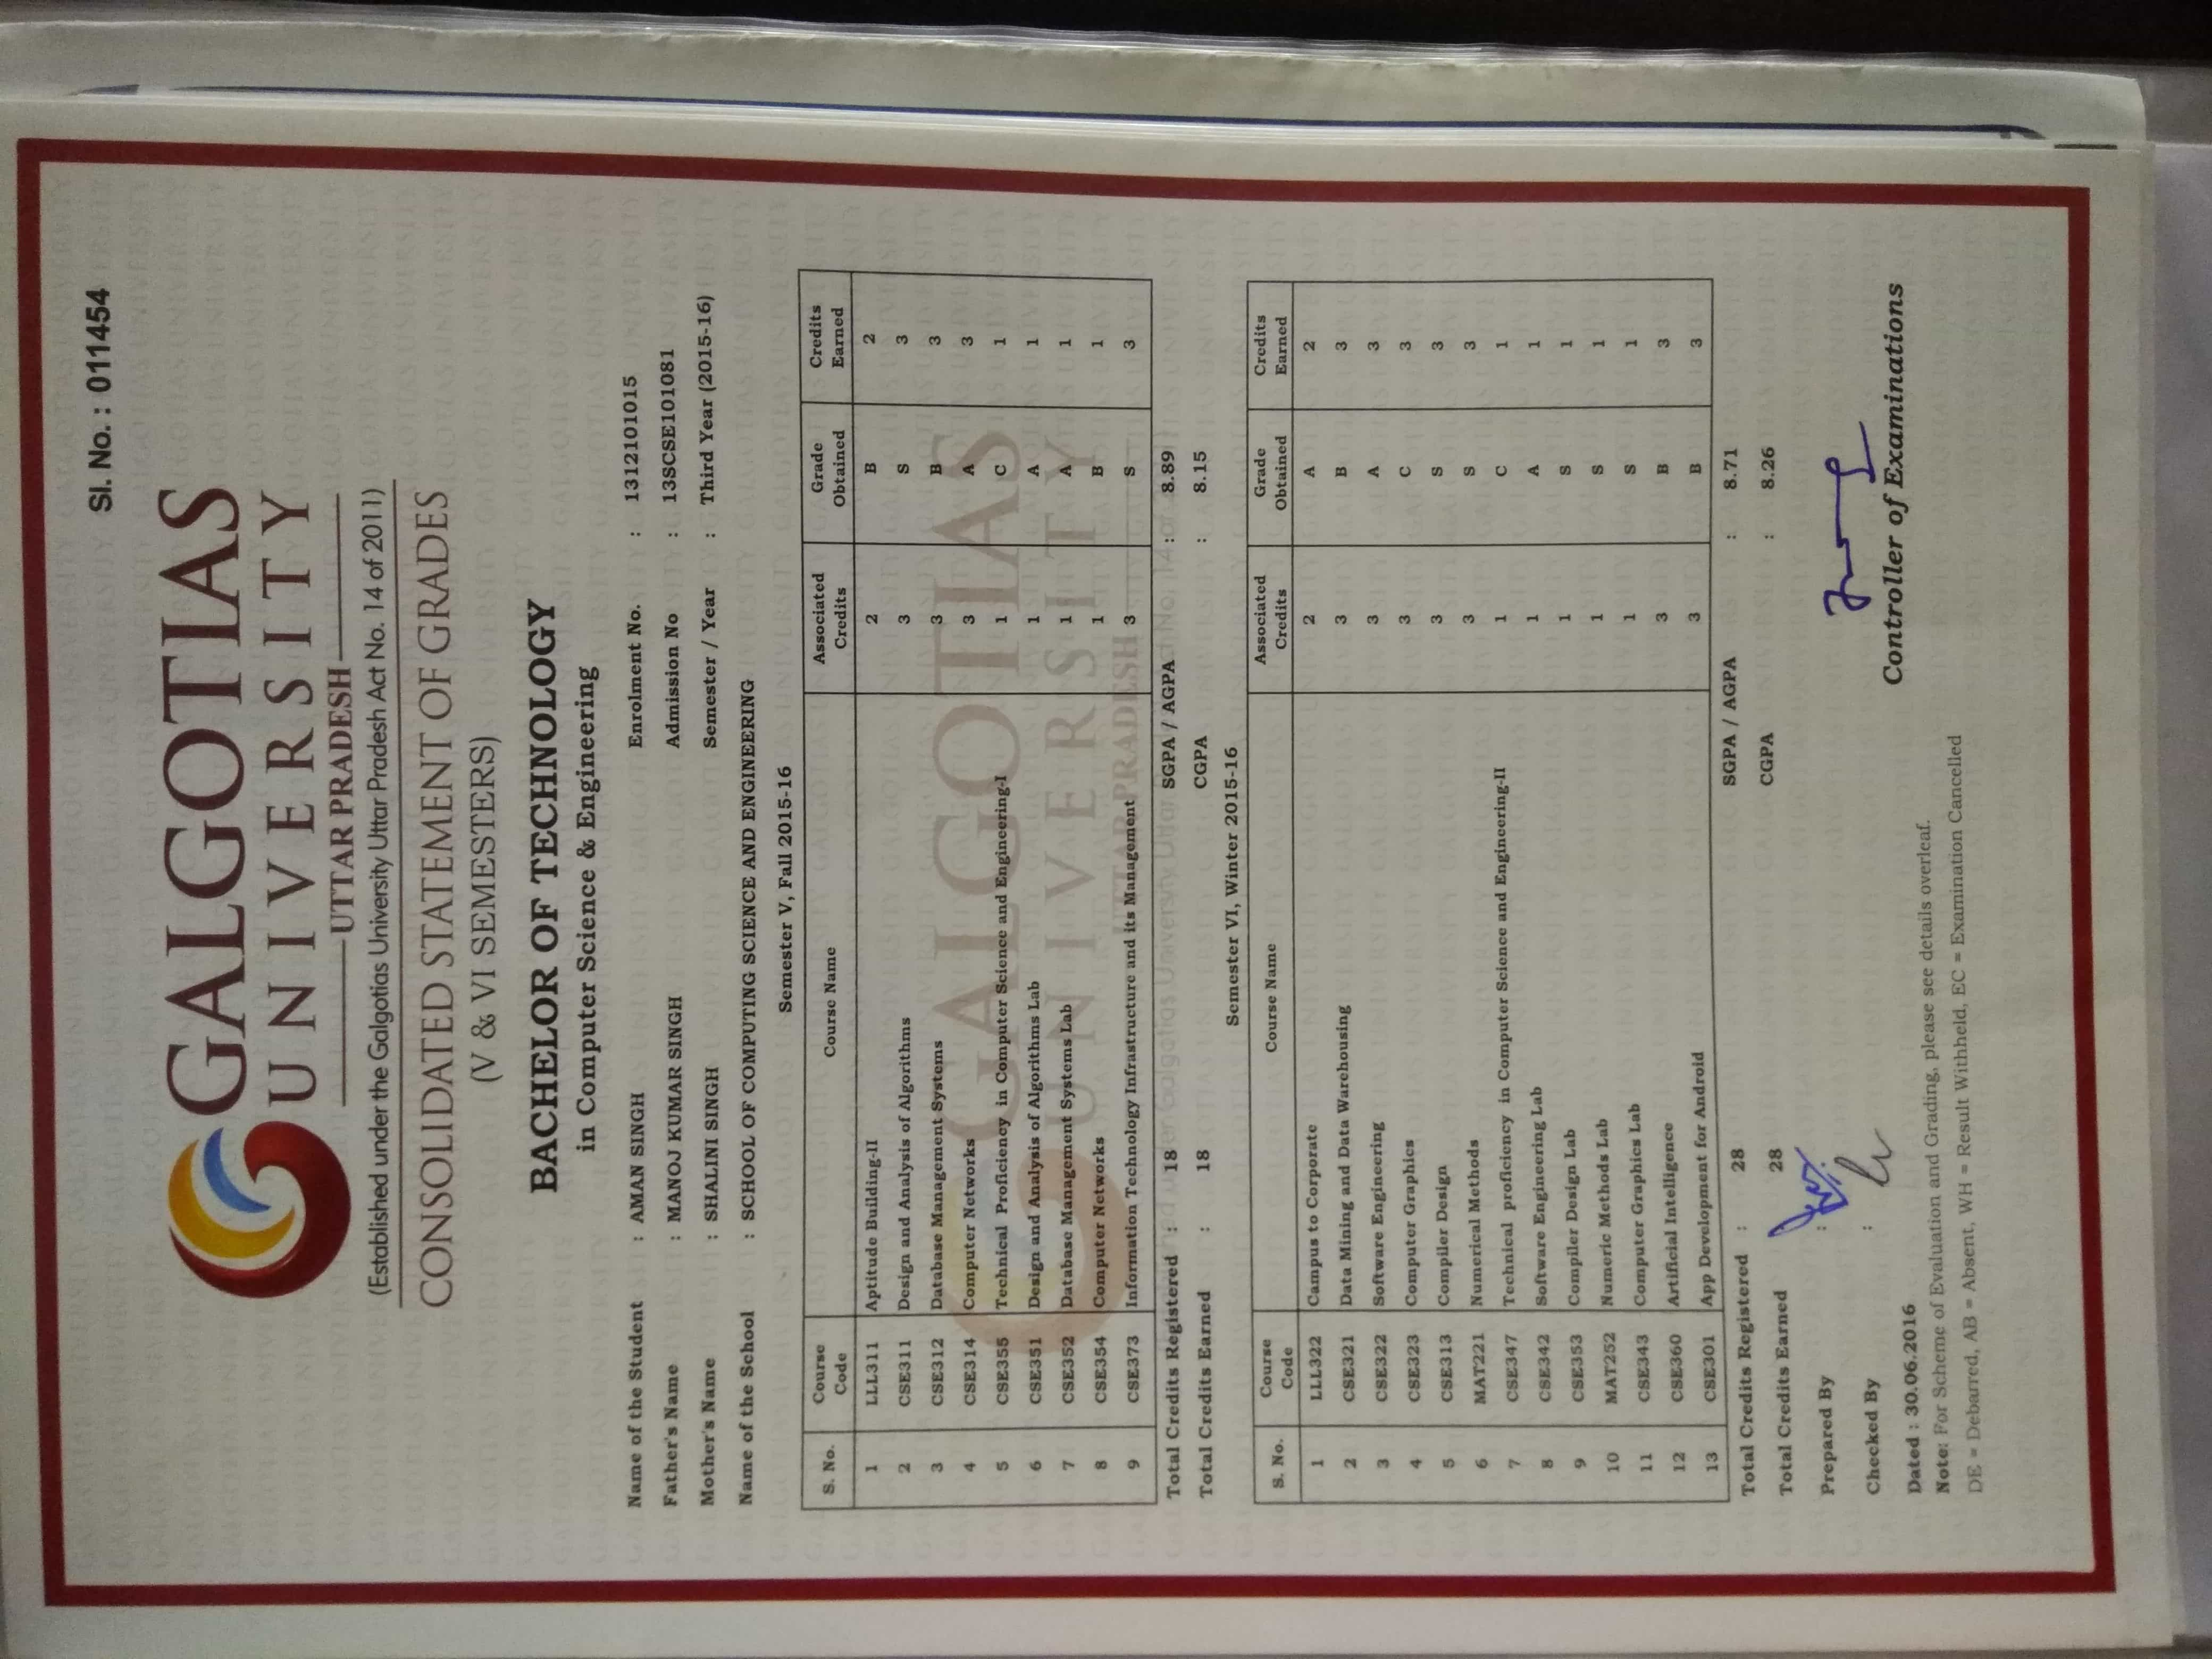

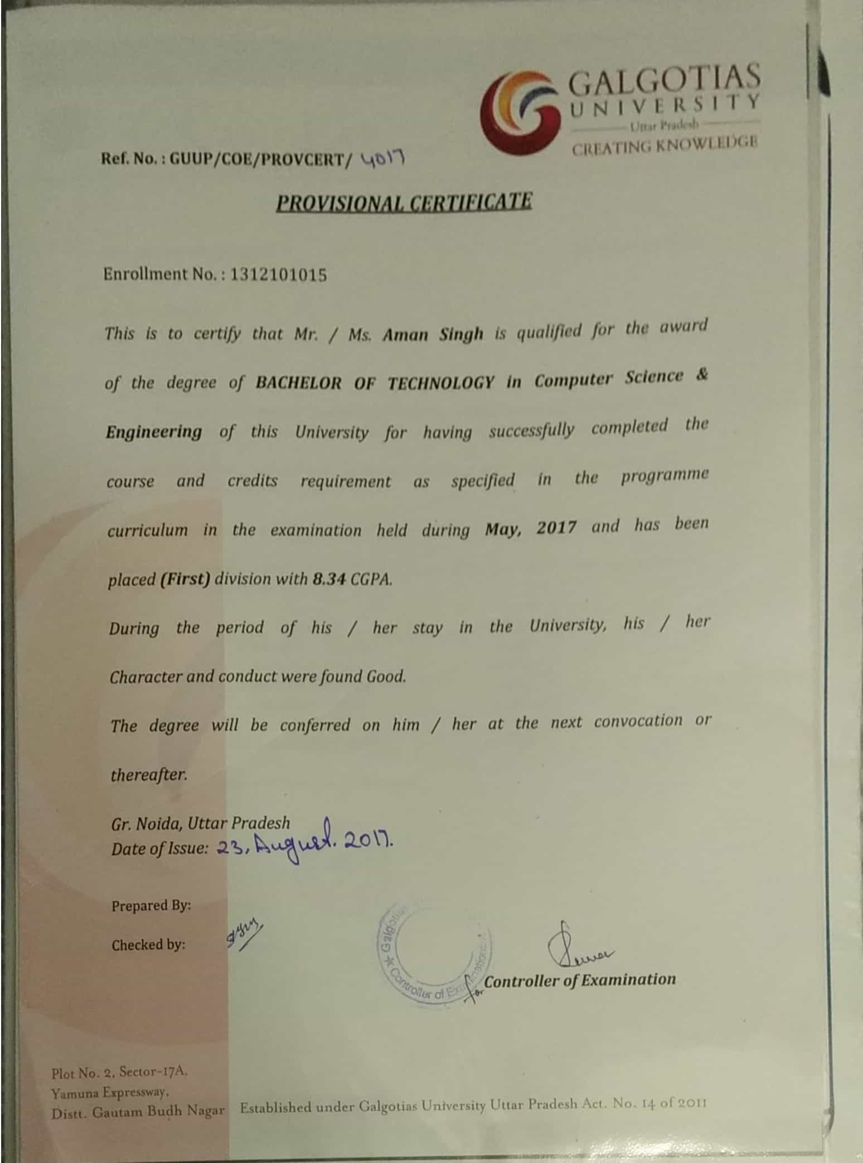

**PREVIOUS EMPLOYMENT DETAILS**

|  |  |  |
| --- | --- | --- |
| **Employment – 1** | | |
| **Name of Company:** | | |
| **Company Address**  **(Where you were employed )** | **Building No & Street:** | |
| **City:** | **State:** |
| **Pin:** | ** (Landline):** |
| **Period of employment:** | | **Employee ID:** |
| **Designation & Department:** | | **Last Drawn Salary (CTC):** |
| **Type of Employment: Permanent [ ] Contractual [ ] Part time [ ] Full Time [ ]** | | |
| **Supervisor’s Name & Designation:** | | **Supervisor’s Direct Number & Mail Id:** |
| Can the employer be contacted now? [ ] Yes [ ] No | | |
| If not, then provide an alternate date: Reason for Leaving: | | |
| **Employment – 2** | | |
| **Name of Company:** | | |
| **Company Address**  **(Where you were employed )** | **Building No & Street:** | |
| **City:** | **State:** |
| **Pin:** | ** (Landline):** |
| **Period of employment:** | | **Employee ID:** |
| **Designation & Department:** | | **Last Drawn Salary (CTC):** |
| **Type of Employment: Permanent [ ] Contractual [ ] Part time [ ] Full Time [ ]** | | |
| Can the employer be contacted now? [ ] Yes [ ] No | | |
| If not, then provide an alternate date: Reason for Leaving: | | |

# **Note: Please attach legible photo copies of the following documents relevant to the entries above.** 1) Relieving Letter 2) Experience certificate 3) Salary Slip

**Certification by Candidate:**

I certify that the information provided in this form is true and correct to the best of my knowledge.

I authorize ***‘*Mindtree’ or its agency** to verify my credentials.

I understand that if any information furnished by me is found to be false, I could be denied employment/be terminated.

I will cooperate and facilitate the process of verification of my credentials.

Signature of the Candidate

Place: Mindtree kalinga

Aman Singh

Date: 08-02-2018

**Authorization Letter**

To whomsoever it may concern

I hereby authorize Mindtree Ltd. to verify my background credentials from its authorized vendors, which includes my current/previous Employment history, Educational/Professional Credentials and my Criminal/Address background check.

Mindtree verification vendors may obtain appropriate information from different sources as per the details mentioned in my application form submitted to my Employer, which includes Employment history from my current/previous employer. Educational/Professional Credentials to be checked from School/College/University/Autonomous institute and my Criminal/Address background check from Civil/Credit violations records.

Mindtree verification vendors reserve the rights to obtain appropriate information from any individual, corporation or any confidential information deemed necessary to check my credentials and furnish the same to my employer.

I unconditionally release all concerned parties from all liabilities that might arise as a result of my background verification check and also do not hold responsible, any individual, corporation or private and public entity as a consequence of this check.

I also authorize release of this information in original, fax or photocopy form as deemed necessary and authenticate the validity of the same.

**Name of the Candidate: Aman Singh**

**Date: 07/02/2018**

**Signature of the Candidate: AMAN SINGH**